2 - Пересечения

select top(1000)
datepart(day,closedate) [день],
datepart(year,closedate) [год] ,
datepart(month,closedate) [месяц] ,
sum(Basesum) [сумма заказов], count(distinct CheckUID)
from sms_izbenka_arc..su_checks (nolock)
where order_id is not null and datepart(year,closedate)=2022
and datepart(month,closedate)=5
group by datepart(year,closedate), datepart(month,closedate), datepart(day,closedate)
Order by datepart(year,closedate), datepart(month,closedate), datepart(day,closedate)

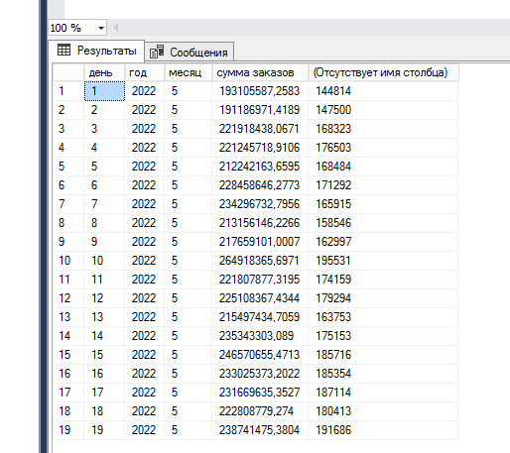

select top(1000)

datepart(day,closedate) [день],
datepart(year,closedate) [год] ,
datepart(month,closedate) [месяц] ,

sum(Basesum) [сумма заказов]
from sms_union..checks (nolock)

where order_id is not null
and datepart(month,closedate)=5
group by datepart(year,closedate), datepart(month,closedate), datepart(day,closedate)
Order by datepart(year,closedate), datepart(month,closedate

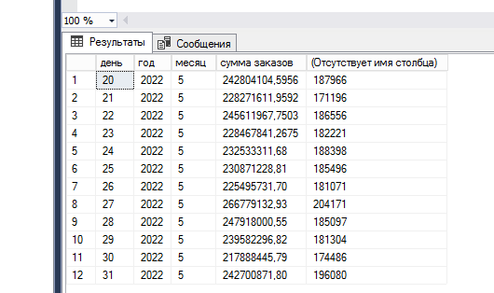

2
select top(1000)
datepart(year,closedate) [год] ,
datepart(month,closedate) [месяц] ,
sum(Basesum) [сумма заказов], count(distinct CheckUID)
from sms_izbenka_arc..su_checks (nolock)
where order_id is not null and datepart(year,closedate)=2022 and datepart(month,CloseDate) in (1,2,3,4)
group by datepart(year,closedate), datepart(month,closedate)
union
select 2022 [год], 5 [месяц] ,
sum(Basesum) [сумма заказов], count(distinct order_id) from
(select distinct order_id, Basesum from (
select order_id, basesum from sms_izbenka_arc..su_checks (nolock)
where order_id is not null and datepart(year,closedate)=2022 and datepart(month,CloseDate)=5
union
select order_id, basesum from sms_union..checks (nolock)
where order_id is not null and datepart(year,closedate)=2022 and datepart(month,CloseDate)=5 )
a ) b
union
select
datepart(year,closedate) [год] ,
datepart(month,closedate) [месяц] ,
sum(Basesum) [сумма заказов], count(distinct CheckUID)
from sms_union..checks (nolock)
where order_id is not null and datepart(year,closedate)=2022 and datepart(month,CloseDate) in (6,7,8,9)
group by datepart(year,closedate), datepart(month,closedate)

